Unit 4 , 4.5
Speech Coding
Speech coding is a digital signal processing technique used to compress speech signals for efficient transmission and storage. It involves converting analog speech into a digital representation, often using fewer bits than the original signal, while maintaining acceptable speech quality. This compression allows for more efficient use of bandwidth and storage space in communication systems.
Note: Trade-off exist between bandwidth utilization and speech quality.
Characteristics of Speech Signal:
Speech waveforms have a number of useful properties that can be exploited when designing efficient coders.
Some of the properties that are most often utilized in speech coder design include.
- Autocorrelation Function (ACF)
- Probability Density Function (PDF)
- Power Spectral Density Function (PSD)
Autocorrelation Function (ACF)
In speech signal there exists much correlation between adjacent samples of the segment of speech.
This implies that in every sample of speech, there is a large component that is easily predicted from the value of the
precious samples with a small random error. All differential and predictive coding schemes are based on exploiting this property.
Autocorrelation function (ACF):
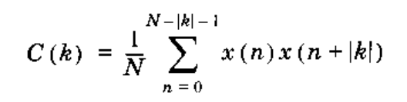
x(k) is kth sample of speech signal.
Typical signals have an adjacent sample correlation, as high as 0.85 to 0.9.
Probability Density Function (PDF)
Speech signal amplitude has a nonuniform probability density function (pdf) denoted by
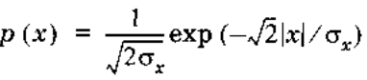
The pdf of a speech signal is in general characterized by a very high probability of near-zero amplitudes, a significant very high probability of near-zero amplitudes, a significant probability of very high amplitudes, and a monotonically decreasing function of amplitudes between these extremes.
Nonuniform quantizers, including vector quantizers, are used to match the distribution by allocating more quantization levels in the regions of high probability and fewer levels in the region where the probability is low.
Power Spectral Density Function (PSD)
Non-flat characteristic of the power spectral density of speech makes it possible to obtain signification compression by coding speech in the frequency domain.
That is, coding the speech signal separately in different frequency bands can leads to significant coding gain.

4.6 Significance of Vocoders and its types (Channel, Formant, Linear Predictive)
A vocoder is an electronic device or software that analyzes and synthesizes human speech or other audio signals, often used to create a robotic or synthesized vocal effect.
Vocoders
Analyze the voice signal at transmitter.
Transmit parameters derived from the analysis.
Then synthesis the voice at the receiver using those parameters.
All vocoder systems try to model the speech generation process as a dynamic system and attempt to quantify certain physical constraints of the system.
These physical constraints are then used to provide a faint description the speech signal.
In general, much more complex than the waveform coders and achieve very high economy in transmission bit rate.
However, less robust, and the performance tends to be talker dependent.
Discussing different types of vocoders:
- Channel Vocoder
- Formant Vocoder
- Linear Predictive Vocoder

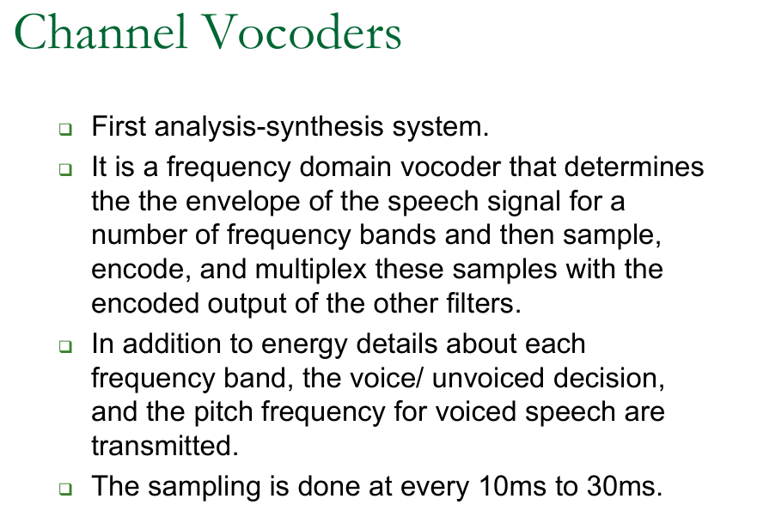

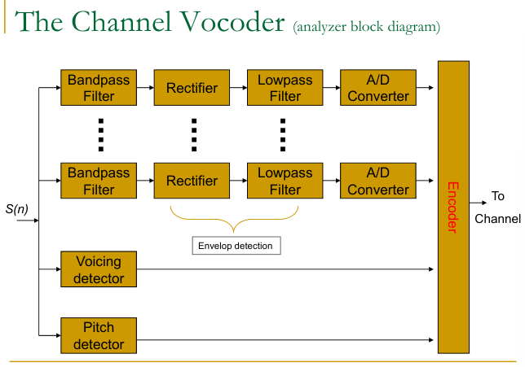
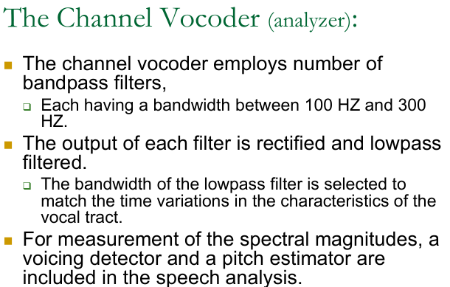
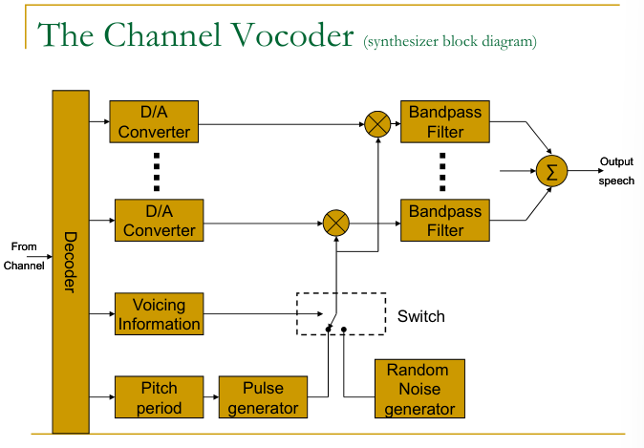
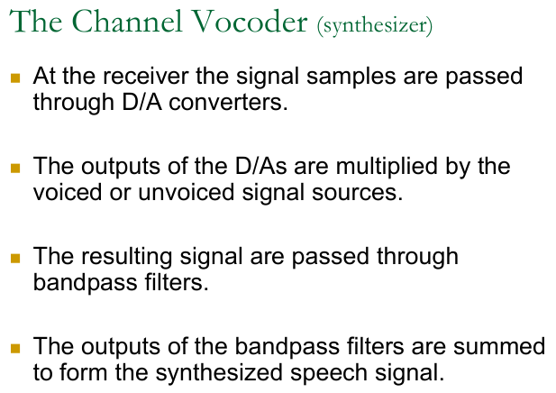

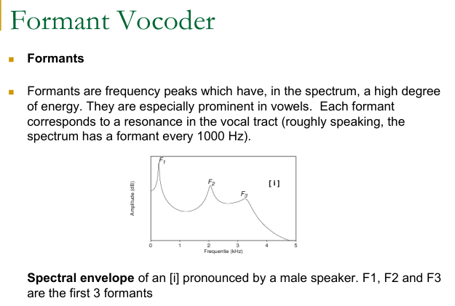
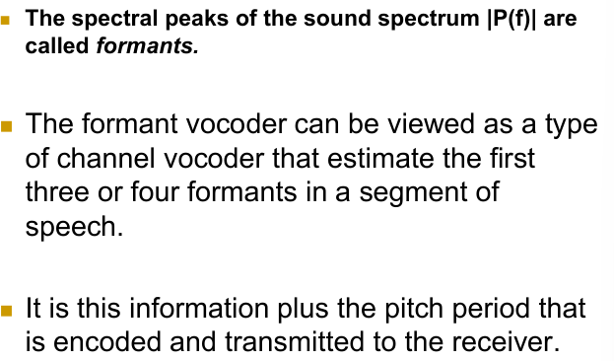

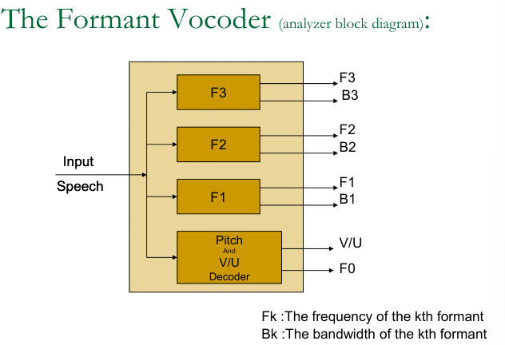
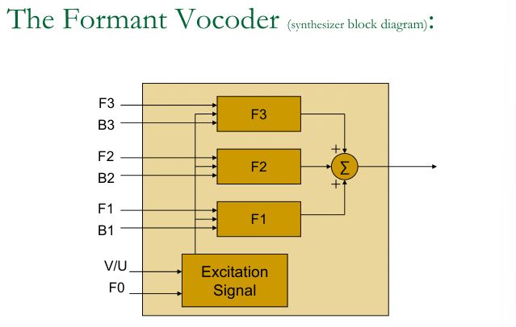
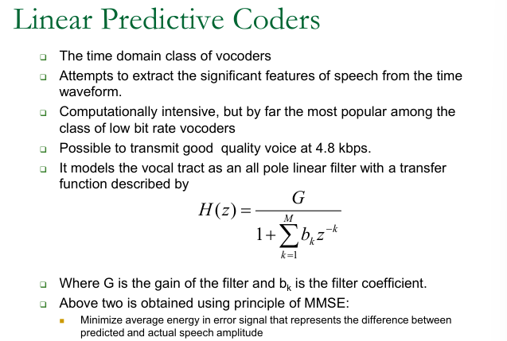
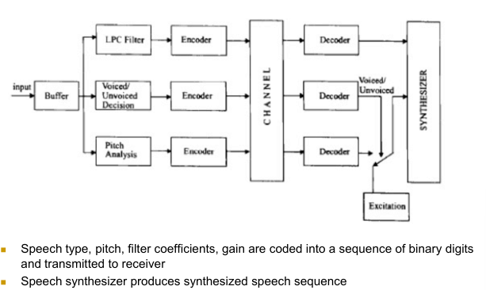

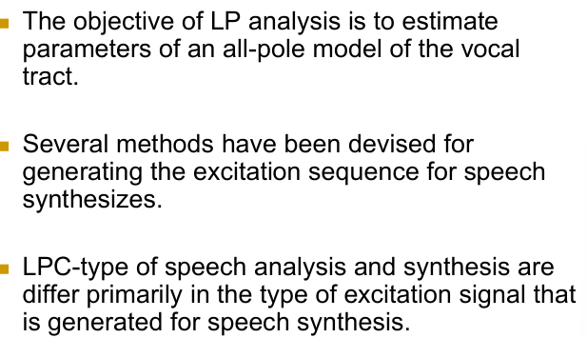
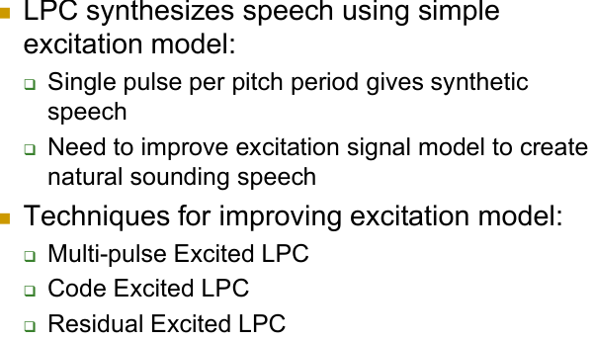

4.7 GSM Codec (Self Study)

